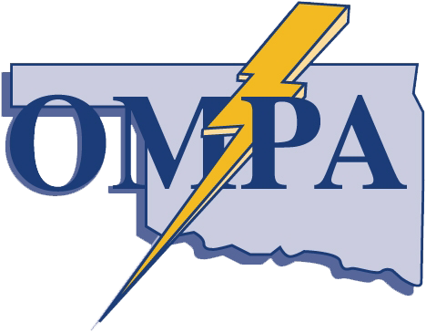
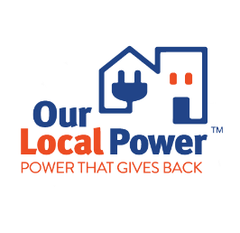
TERMS AND CONDITIONS:
Turn Down The Watts, Bring-Your Own-Device (“BYOD”) Demand Response (“DR”) Program from Oklahoma Municipal Power Authority (“OMPA”)

The Turn Down The Watts program provides eligible residential electric customers, of an OMPA member owned utility that receives power from OMPA, the opportunity to receive a one-time enrollment incentive, and an annual participation incentive, for allowing OMPA to control a qualifying enrolled smart thermostat during times of peak system demand. Demand Response programs lower energy consumption, cut carbon emissions, and help safeguard the grid during times of peak energy use, and electric system constraints.

CUSTOMER ELIGIBILITY REQUIREMENTS:
- The customer must be a residential electric customer of an OMPA member city that receives power from OMPA.

- The customer must be an active account holder at the address where the smart thermostat is installed.

- The customer can own or rent the residence where the smart thermostat is installed.

- The installed smart thermostat must be a qualifying Amazon, Google Nest, Honeywell, Emerson, Sensi, or Ecobee Wi-Fi enabled smart thermostat.

- The installed smart thermostat must operate a working central heat and air, or heat pump system in good mechanical condition.

- The customer must have a Wi-Fi network that is compatible with the installed smart thermostat.

- The customer agrees to maintain the installed smart thermostat’s Wi-Fi connectivity.

- The customer agrees to allow OMPA to use energy data acquired from the installed smart thermostat, to measure the impact on consumption during peak energy events.

ACCESS AND CONNECTION:
To participate, you must allow OMPA access to control your device. This means that you must have (i) a working and reliable internet connection, Wi-Fi network, and other related equipment in your home, which is positioned to communicate reliably; (ii) an internet service provider, ("ISP"); (iii) and other system elements that may be specified as required by OMPA or the manufacturer of any required equipment or programs (i.e., smart phone apps).
You are responsible for all fees charged by the ISP in connection with participation in the Turn Down The Watts BYOD DR Program. Your participation in the Turn Down The Watts BYOD DR Program will be terminated if OMPA is unable to communicate with or access the thermostat, and communication or access is not restored within 30 days after notice from OMPA. If communication or access is restored at a future date, you may opt back in. Reconnection as provided herein may only happen once annually.

DEVICE PERFORMANCE:
If the device system fails to perform, you will have thirty (30) days to resolve the issue and have OMPA test and verify that performance has been restored. If performance is not restored within thirty (30) days, OMPA may elect to terminate your participation in the Turn Down The Watts BYOD DR Program.

CONTROL OF DEVICE:
You acknowledge that OMPA will control the thermostat or device system in your home and agree that OMPA may access and control your thermostat or device system during peak energy events and other periods, to benefit grid services such as peak reduction, as well as other ancillary services. A "Peak Energy Event" is defined as a period in which OMPA will make necessary changes to the thermostat. Peak events are anticipated to occur no more than six (6) times per month, for no more than three (3) hours per event. Customers will be notified of a peak event, via a smartphone app or other electronic method, at least four (4) hours in advance. There will be no more than twenty (20) peak energy events per calendar year.

ACKNOWLEGMENT OF CUSTOMER:
Customer acknowledges and agrees that OMPA will be permitted to control the device system associated with the Turn Down The Watts BYOD DR Program that is installed in your home. You acknowledge that you remain responsible for maintenance, repair, and replacement of the device system.

PROGRAM COMMUNICATION:
Customers enrolled in the Turn Down The Watts BYOD DR Program will be notified of a peak event through SMS, by the smart thermostat manufacturer via a mobile app, or by the thermostat. By providing a cellular phone number and an email address, you agree to receive text messages, voice messages, and/or emails regarding peak energy events.

PARTICIPATION IN PEAK ENERGY EVENTS:
During peak events, you agree to allow OMPA to adjust the temperature of your installed smart thermostat by no more than three (3) degrees, from the smart thermostat’s normal temperature setting. Peak events are typically called during the hours of 10am-8pm. The peak events are initiated when OMPA forecasts a peak event and initiates a signal to enrolled customers’ thermostats.
When signaled, a peak event will have a duration of no more than three (3) hours. Customers will receive a notification via SMS, by the smart thermostat manufacturer via a mobile app, or by the thermostat prior to a called peak event. If the thermostat functionality allows for pre-cooling, OMPA will pre-cool the house by two (2) degrees prior to a called peak event. Once the called peak event is over the thermostat will resume normal operation.

ENROLLMENT AND TERM:
You agree to participate in the Turn Down The Watts BYOD DR Program for twelve (12) consecutive months, beginning with the date of enrollment. You will remain in the program each year until you decide to opt-out of the program, or OMPA decides to terminate your participation. Either party may terminate this Agreement by providing the other party thirty (30) days' written notice of termination.

CUSTOMER COMPENSATION:
Eligible Customers will receive a one-time fifty ($50) dollar enrollment incentive, in the form of a gift card chosen by the customer. A customer must remain enrolled for twelve (12) consecutive months after receiving the one-time enrollment incentive. Only one incentive per eligible thermostat enrolled in the program is available.

Customer agrees to stay enrolled in the program for twelve (12) consecutive months to receive an annual incentive of fifty ($50) dollars for program participation. Customers will receive the annual incentive in the form of a gift card, chosen by the customer, on each year of the customer’s anniversary date of enrollment.

LIABILITY:
OMPA shall not be liable for any direct, indirect, special, or consequential damages to any persons or property resulting from or arising out of any use, repair, delay in repairing, replacement of, modification to, unavailability of, or status of the smart thermostat. OMPA is not responsible for any costs related to the repair, maintenance, or replacement of the smart thermostat. If replacement of your smart thermostat is necessary, you must notify OMPA.

INDEMNIFICATION:
You shall indemnify and hold harmless OMPA, their affiliates, contractors, officers, directors, employees, agents, successors, and representatives (collectively, the “Indemnified Parties”) from and against any and all claims, injury, losses, expenses, or damages to any persons or property arising from OMPA's access and use of the smart thermostat, your participation in the Turn Down The Watts BYOD DR Program, or caused by any breach of this Agreement by you, or your negligence, or that of your household members, agents, servants, employees, tenants, licensees, invitees, tenant's invitees, or independent contractors.

NOTICE AND MISCELLANEOUS:
You must send any Notice required under this Agreement to thermostatdr@ompa.com.
This Agreement shall be governed by the laws of the State of Oklahoma. Any change to the terms of this Agreement must be in a writing signed by you and OMPA.

By enrolling in the Turn Down The Watts BYOD DR Program, the customer states that they have read, understand, and agree to the above terms.

* Google Nest is a trademark of Google LLC *

