Heat pumps are an excellent choice for a residential HVAC system, especially in moderate climates. A versatile heating and cooling system, a heat pump can both heat and cool a home by extracting heat energy from the surrounding environment and moving it to another location. In the winter, this means extracting heat from the outdoor air and moving it inside to provide warmth and comfort. In the summer, this means taking heat energy from indoor air and moving it outside the home. But, how does a heat pump work?
Heat Pump Basics
What is a heat pump? Heat pumps transfer heat from one place to another. Air source heat pumps do not generate heat, they move heat between the air outside a home and the air inside a home. A furnace creates heat that is distributed throughout a home, but a heat pump absorbs heat energy from the outside air (even in cold temperatures) and transfers it to the indoor air. When in cooling mode a heat pump and an air conditioner are functionally identical, absorbing heat from the indoor air and releasing it through the outdoor unit.

Heat Pump Components

Outdoor Unit
The outdoor unit contains a coil and a fan. The coil operates as either a condenser (in cooling mode) or an evaporator (in heating mode). The fan blows outside air over the coil to facilitate the heat exchange.

Indoor Unit
Like the outdoor unit, the indoor unit, commonly referred to as the air handler unit, contains a coil and a fan. The coil acts as an evaporator (in cooling mode) or a condenser (in heating mode). The fan is responsible for moving air across the coil and throughout the ducts in the home.

Refrigerant
The refrigerant is the substance that absorbs and rejects heat as it circulates throughout the heat pump system.

Compressor
The compressor pressurizes the refrigerant and moves it throughout the system.

Reversing Valve
The part of the heat pump system that reverses the flow of refrigerant, allowing the system to operate in the opposite direction and switch between heating and cooling.

Expansion Valve

The expansion valve acts as a metering device, regulating the flow of the refrigerant as it passes through the system, allowing for a reduction of pressure and temperature of the refrigerant.
How a Heat Pump Works - Cooling Mode
One of the most important things to understand about heat pump operation and the process of transferring heat is that heat energy naturally wants to move to areas with lower temperatures and less pressure. Heat pumps rely on this physical property, putting heat in contact with cooler, lower pressure environments so that the heat can naturally transfer. This is how a heat pump works.
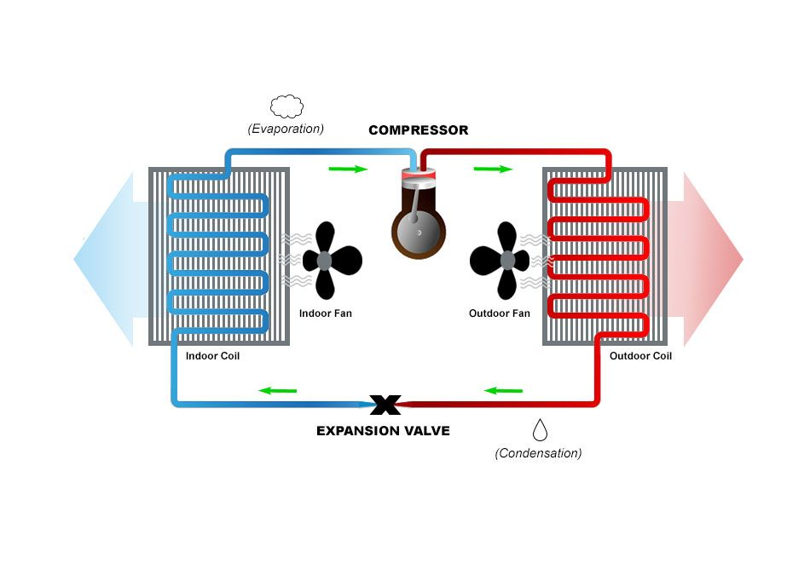

Step 1
Liquid refrigerant is pumped through an expansion device at the indoor coil, which is functioning as the evaporator. Air from inside the house is blown across the coils, where heat energy is absorbed by the refrigerant. The resulting cool air is blown throughout the home’s ducts. The process of absorbing the heat energy has caused the liquid refrigerant to heat up and evaporate into gas form.

Step 2
The gaseous refrigerant now passes through a compressor, which pressurizes the gas. The process of pressurizing the gas causes it to heat up (a physical property of compressed gases). The hot, pressurized refrigerant moves through the system to the coil in the outdoor unit.

Step 3
A fan in the outdoor unit moves outside air across the coils, which are serving as condenser coils in cooling mode. Because the air outside the home is cooler than the hot compressed gas refrigerant in the coil, heat is transferred from the refrigerant to the outside air. During this process, the refrigerant condenses back to a liquid state as it cools. The warm liquid refrigerant is pumped through the system to the expansion valve at the indoor units.

Step 4
The expansion valve reduces the pressure of the warm liquid refrigerant, which cools it significantly. At this point, the refrigerant is in a cool, liquid state and ready to be pumped back to the evaporator coil in the indoor unit to begin the cycle again.
How a Heat Pump Works - Heating Mode
A Heat pump in heating mode operates just like cooling mode, except that the flow of refrigerant is reversed by the aptly named reversing valve. The flow reversal means that the heating source becomes the outside air (even when outdoor temperatures are low) and the heat energy is released inside the home. The outside coil now has the function of an evaporator, and the indoor coil now has the role of the condenser.
The physics of the process are the same. Heat energy is absorbed in the outdoor unit by cool liquid refrigerant, turning it into cold gas. Pressure is then applied to the cold gas, turning it to hot gas. The hot gas is cooled in the indoor unit by passing air, heating the air and condensing the gas to warm liquid. The warm liquid is relieved of pressure as it enters the outdoor unit, turning it to cool liquid and renewing the cycle.
How a Heat Pump Works – Review
A heat pump is a versatile, efficient cooling and heating system. Thanks to a reversing valve, a heat pump can change the flow of refrigerant and either heat or cool a home. Air is blown over an evaporator coil, transferring heat energy from the air to the refrigerant. That heat energy is circulated in the refrigerant to a condenser coil, where it is released as a fan blows air across the coil. Through this process, heat is pumped from one place to another.

