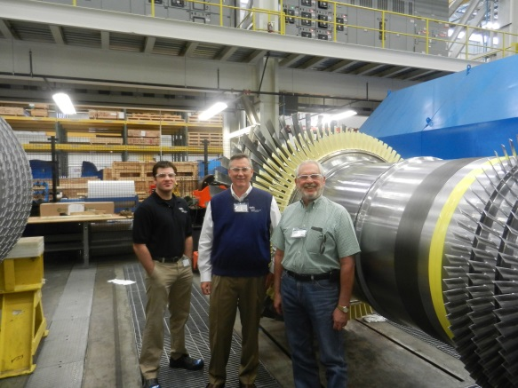
May 2014 Update:
Construction of the Charles D. Lamb Energy Center continues. On June 2, 2014 David Osburn, OMPA General Manager; Mike Mushrush, OMPA Director of Operations and Charles D. Lamb, Mayor of Edmond visited the Siemens factory in Charlotte, North Carolina to view the build on the Gas Turbine for the CDLEC.
May 2014 Accomplishments:
–Installed Duct Bank 2
–Completed CTG Foundation Installation
–Completed GT Power Control Foundation
–Completed GSU Foundation
–Completed UAT Foundation
–HDPE Fire Water and Primary Water service piping installation progressing
–Construction of the 345kV substation with OG&E progressing
Overall Construction Progress: 14%

